Digital Assignment #1: Industrialization and Urbanization
Directions: Use your readings and your own research to respond to the following. Be detailed!

Part 1: Important Terms
Concept or Idea | Response | Visual Image
Industrial  Capitalism | How did men like Rockefeller, Carnegie, Morgan, and Ford change the social, political, and economic landscape of the nation? What did each one do? How do we see their impact today?  Henry Ford worked as an engineer before he became an automobile mogul. Through the confidence from Edison, Ford was able to build a gas powder care and advised Edison on finding a rubber substitute. By this, they contributed to the social and economic welfare of the nation.  Through his steel plant, Carnegie changed the country's economy through industrialization and job opportunity creation. Morgan steered the U.S. out of the financial crisis. During the 1907 panic, he locked the top bankers, where he forced them to discuss his saving economy plan. Ultimately, he convinced them to contribute their money for keeping the troubled thrusts of the country afloat. Rockefeller was the founder of the Standard Oil Trust and led to the growth of the country's economy. Additionally, he influenced the political state of the country.  Their impacts are still evident today in all the aspects of social, economic, and political. Through their industrial inventions, the state grew rapidly. The use and operations of motor vehicles and types of machinery today result from their industrial inventions.
Western  Expansion | How did western Native Americans respond to the nation’s expansion westward? Did some of them resist? Assimilate? Which ones? Why?  The native Americans moved from their lands for making way for the railroad and the homesteads. However, some of them resisted the nation's expansion while others assimilated. The plain Indians resisted the expansion since ranching impacted change. The majority of the nomadic tribes were restricted in their free-roaming ability when the land was roped off. The Indians were also assimilated since they wished to enjoy the western culture and the privileges that were enjoyed by the whites.
Professionalization of Sports | In what ways were sports changed, and how did they change American culture's social fabric in the 19th century? How were African Americans incorporated into sports? How did athletes’ lives/economics change?  There was increased coverage of sports by the newspapers. Roads improvements enabled the sports fans to travel in distant cities for athletic events. Large numbers started to pay money for watching other persons competing in the athletic contests. They led to an increase in the influence of modern popular culture and reflected the standards and social attitudes changing. The African Americans were incorporated into the sports through the protests that served a warning to the intercollegiate sports, where every major team took a step to sign a black athlete, which led to a change in the sport. Through sports, the athletes' living standards have drastically improved, and their lives are made better and comfortable.
Entertainment | In what ways did Minstrel shows and artistic realism change the way that Americans entertained themselves? Who were their main targets? What was the underlying message?  They became the national art form and translated formal art form like opera to popular terms for the general audience.  The main targets of the Minstrel shows were the black people. Minstrel's underlying message shows lampooned black people as buffoonish, lazy, dim-witted, happy, and superstitious.
Immigration | Name some of the ways immigration affected American culture? How did native-born Americans react to immigrants and the cultural diversity they brought with them? How did immigrants change cities like New York? Chicago? San Francisco?  Immigration expanded the American culture by the introduction of new customs and ideas by the immigrants. They also, through hard work and entrepreneurship, improve the economies.  The native-born Americans were hostile immigration profoundly. They felt the cultural diversity posed a threat to their way of life and felt that immigrants were strange individuals speaking strange languages that they could not understand.  Immigration impacted the cities by increasing the population's overall growth, which led to the growth of the infrastructure. Additionally, the cities experienced less skilled rising share.
Urbanization | What impact did Jacob Riis’ How the Other Half Lives have on the nation? How did people react to these?  It stimulates curbing of poor conditions by the legislation in the tenant housing leading to better living conditions of persons in the nation. People reacted overwhelmingly to it by massively buying it and inspired Roosevelt to close the worst tenant's houses. People highly embraced it.
Part 2: Collage: Create a collection of pictures that you believe capture the beginnings of turn-of-the-century capitalism throughout the United States. Make it look as professional/artistic as you can. No explanations are needed.
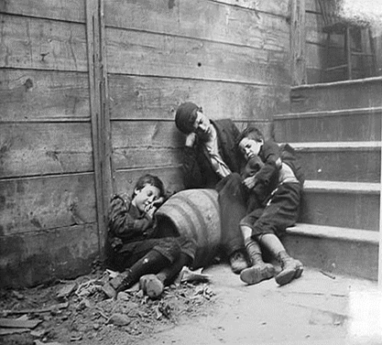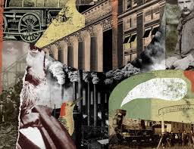

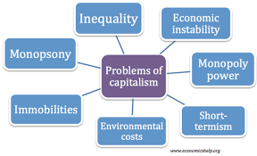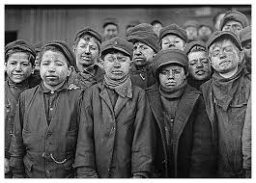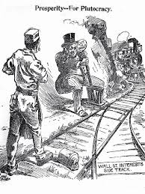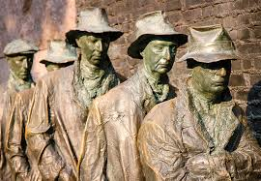

Part 3: You are (a) an African American athlete of the late 19th century, (b) a young native American boy forced to go to an American boy's school, or (c) a woman who wants the right to vote. Please write a letter to your descendants – 100 years into the future (now) – what life was like for you and how it changed. The length of the letter should be no less than 500 words. Be as descriptive and as historically factual as you can.
Dear Descendants,
I write this letter to inform you of the sorrow and agony that women who have been denied their democratic right to vote went through. The right and freedom to vote has been denied to women who are not believed to play any role in this country's leadership. It is even more painful to see women being subjected to unfair treatment, which they have no control to simply because they do not have the freedom to choose their representatives.
Life is challenging and difficult. Mothers and women are neglected and treated unfairly. Their decisions and desires are not of matter to society. Power is for the strong and those who have masculine. It's so pathetic for women whom I think their rights should be taken care of. Mothers are only subjected to only the household duties and responsibilities and giving birth. Women are enslaved and taken for granted.
As I write this letter, my main desire is to vote to have the control of the leadership that will govern us and will create a suitable environment for you when your time comes. Good leadership determines the future. Suppose only women could be granted the opportunity to vote. In that case, a better and great future is guaranteed as they will vote for a representative who will represent their needs and desires and those for their future generations.
Many things have changed since. Women have fought for their democratic rights and now have the freedom and right to participate in the voting process. Not only gaining the voting right, but they are also eligible for vying to be voted for and represent in the leadership positions where they do participate in the development of the country. The way you find life now wasn't the case a hundred years. Life has changed for the better. Things are now good. Women are respected and their rights too. Kindly take care of the golden opportunity.

Yours faithfully,
Great grandmother

